DOI:10.31557/rro.2386.20240827

Drug-induced Vasculitis in a Breast Cancer Patient Receiving Chemotherapy
CASE REPORT
Omidvari SH¹, Nasrolahi H*¹, Javid SA², Hamedi SH¹, Mohammadianpanah M³,
Ansari M¹, Ahmadloo N¹, Mosalaei A⁴
- Department of Radiation Oncology, Nemazee Hospital, Shiraz University of Medical Sciences, Shiraz, Iran.
- Dr. Javid Laboratory, Shiraz, Iran.
- Colorectal Research Center, Shiraz University of Medical Sciences, Shiraz, Iran.
- Shiraz Institute for Cancer Research, Shiraz University of Medical Sciences, Shiraz, Iran.
*Corresponding Author: : Nasrolahi H
Email: nasrolahihamid@yahoo.com
Abstract
Introduction: Drug-induced vasculitis following chemotherapy has been rarely reported. We report such a case of drug-induced vasculitis following chemotherapy in a breast cancer patient.
Report of the Case: A 52 year old woman with stage III breast cancer developed pathologically proven vasculitis presenting as bilateral severe erythema, edema and ulceration on both feet 10 days following the 4th cycle of adjuvant chemotherapy. Chemotherapy consisted of docetaxel, doxorubicin, and cyclophosphamide in each cycle that was preceded by premedication including dexamethasone, granisetron, and H1 and H2 blockers. Furthermore, filgrastim (5µg/kg) was administered following each cycle of chemotherapy during days 5-9. By discontinuing chemotherapy and starting high-dose intravenous methylprednisolone, vasculitis was resolved. The patient did not experience vasculitis following the re-challenge of chemotherapy excluding docetaxel and filgrastim.
Conclusion: This case suggests that docetaxel and filgrastim might be added to the list of agents causing drug- induced vasculitis.
Key words: Drug-induced, vasculitis, docetaxel, filgrastim, breast cancer.

Introduction
Cutaneous vasculitis is a disease of small vessels which may present as a benign self-limited disease or conversely, an extensive disease with multiple organs involvement ^{(1,} ²⁾. The antigen that may start the hypersensitivity may be an infective agent, a drug, or even an autoantibody against the patient’s tissue ⁽²⁾. Approximately one fifth of skin vasculitides are drug-induced. Most of the drug-induced vasculitides (DIV) have skin manifestations. In cases with DIV, the mechanism of injury may be cell- mediated or humoral immunity ⁽²⁾. Discontinuing the responsible agent is often the required initial treatment. Occasionally, administration of corticosteroid or immunosuppressive drugs may be necessary ⁽³⁾.
Breast cancer is the most common cancer as well as the leading cause of cancer related deaths among women ⁽⁴⁾. Hormone therapy and chemotherapy are the most frequent systemic treatments used

for these patients. Although tamoxifen causes skin rashes in 19% of cases, the development of overt vasculopathy is very rare ⁽⁴⁾. Chemotherapy- induced vasculitis has been reported exceptionally. In this report, we describe a breast cancer patient who developed vasculitis following the 4th cycle of chemotherapy.

Report of the case
The patient was a 52-year-old woman who was diagnosed as stage III (T3N3M0) infiltrating ductal carcinoma of the right breast. The tumor was negative for estrogen and progesterone receptors; however, was strongly (3+) positive for Her2/neu. Accordingly, 6 cycles of adjuvant chemotherapy consisting of docetaxel (75 mg/m²), doxorubicin (50 mg/m²), and cyclophosphamide (500 mg/m²) was determined as the patient’s treatment course. Premedication consisted of dexamethasone

Reports of Radiotherapy and Oncology | Vol.1 | No.2 | Summer 2013 | 81

Omidvari et al.

and granisetron. Also H1 and H2 blockers were prescribed intravenously before each cycle of chemotherapy. In addition, prophylactic colony stimulating factor (as 5 µg/kg filgrastim) was administered following each cycle of chemotherapy during days 5-9.
Following the first 3 cycles of chemotherapy, the patient developed a mild self-limiting skin erythema. Few days after the 4th cycle of chemotherapy she developed bilateral severe erythema and edema of feet, particularly on right foot associated with ulceration (Figure 1). The renal function tests and chest X ray were normal and the patient had no other systemic complaints. A biopsy from the skin of the left foot revealed
vasculitis (Figure 2). Therefore, chemotherapy was discontinued and the patient received high-dose intravenous methylprednisolone. Subsequently, the patient’s skin lesions healed (Figure 3); and chemotherapy re-started with doxorubicin (60 mg/ m²) and cyclophosphamide (600 mg/m²), excluding docetaxel and filgrastim. She completed her 6 cycles of chemotherapy without developing any cutaneous events.
Discussion
Sulfadiazine and hydralazine were among the first drugs known to cause DIV . Approximately 7% of patients who receive hydralazine develop DIV ⁽³⁾. Other drugs that may result in rheumatologic side

Reports of Radiotherapy and Oncology
82

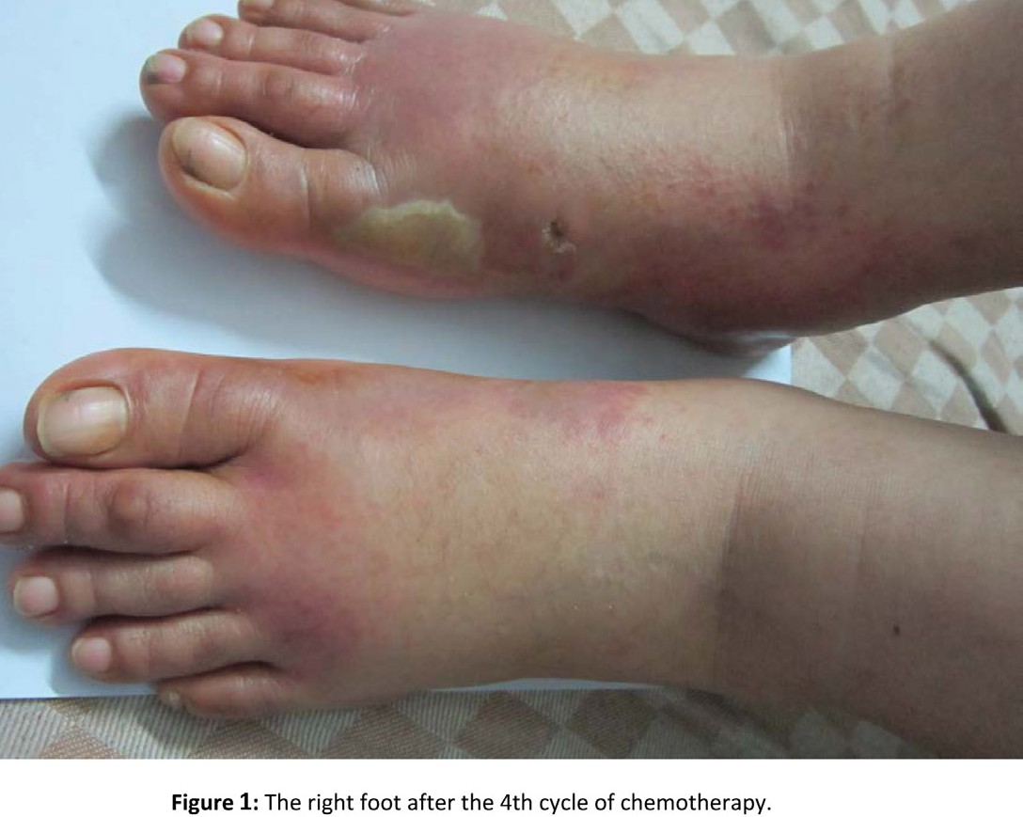
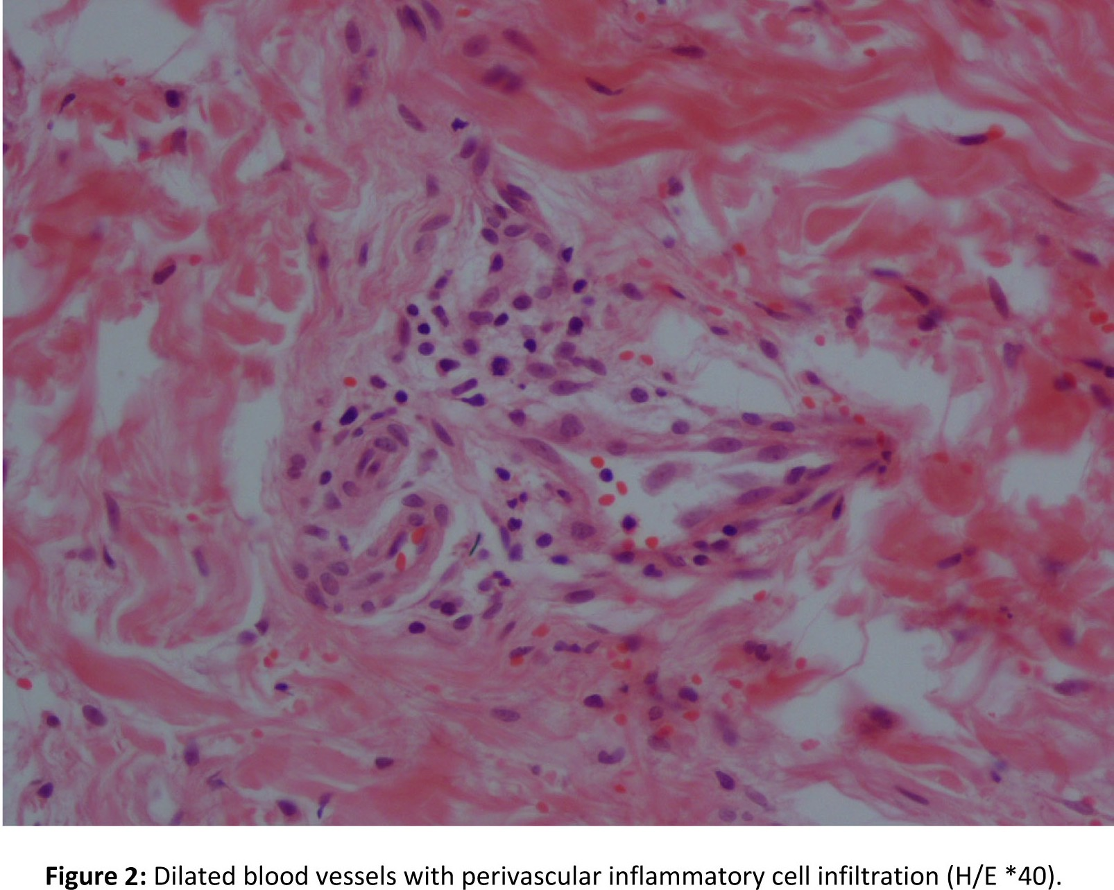

Drug-induced vasculitis in a breast cancer patient ...

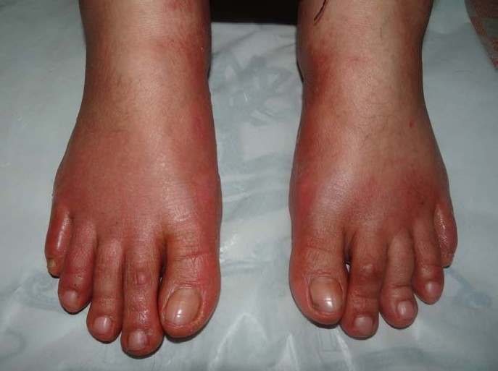
Figure 3: The right foot after treatment with corticosteroid.

effects include propylthiouracil, carbamazepine, allopurinol, cefotaxime, chlorpromazine, isoniazid, alpha methyldopa, minocycline, phenytoin, procainamide, quinidine, and many others ^{(4,5)}.
Clinical presentations of primary vasculitis and DIV are similar and depend on the site of involvement. Discrimination between these two types of vasculitis is difficult; however, systemic involvement is generally less frequent in DIV. Systemic involvement, if present, may involve kidneys, joints and lungs ^{(1,} ³⁾. In DIV, the most common presentation is palpable purpura, while our patient presented with severe erythema, edema and ulceration ⁽¹⁾. There are also a few reports of other organs such as brain and bowel as the sole sites of involvement ^{(6,} ⁷⁾. Some patients may need the immunosuppressive treatment with corticosteroids and cyclophosphamide or even plasmapheresis ^{(2,} ³⁾. However there are a few reports of fulminant vasculitis with catastrophic outcomes despite aggressive treatment in the literature ^{(6,} ⁸⁾.
Among agents that are used for treatment of cancer, anastrozole, tamoxifen, filgrastim and gemcitabine have been reported to cause vasculitis ^{(2,} ^{4,} ^{6,} ^{7,} ^{9,} ^{10,} ¹¹⁾. In drug induced vasculitis, the histological pattern is similar to other vasculitides ⁽¹²⁾. The initial treatment of vasculitis used to be long-term administration of cyclophosphamide and steroid; however, due to the high mortality rate and numerous side effects, this treatment is rarely used nowadays ^{(13,} ¹⁴⁾.
Naranjo scale that was proposed in 1981 is a causality rating score that relates a drug to a reaction. It is consisted of 10 items including
previous reports, time of drug administration and occurring reaction, reappearing with the same drug, blood level of the drug and some other factors. Other simpler scales are also proposed that are more applicable. In this study we used WHO scale for causality assessment ⁽¹⁵⁾. According to this scaling assessment, the patient’s vasculitis was probably related to docetaxel and filgrastim. The clinical course of the patient’s vasculitis and its’ rapid response to the intravenous high-dose corticosteroid suggests DIV rather than primary vasculitis. Obviously re-challenge of suspected drug might be fatal and not possible for this patient.

Conclusion
This case suggests that docetaxel and filgrastim might be added to the list of agents that can cause drug-induced vasculitis.

References
- Bahrami S, Malone JC, Webb KG, Callen JP. Tissue eosinophilia as an indicator of drug-induced cutaneous small-vessel vasculitis. Arch Dermatol. 2006;142(2):155-61.
- De Sanctis V, Marignani M, Angeletti S, Assisi D, Armosini V, Valeriani M, et al. Anti-Helicobacter pylori therapy in primary MALT lymphoma of rectum. Tumori. 2012;98(4):e105-10.
- Wiik A. Drug-induced vasculitis. Curr Opin Rheumatol. 2008;20(1):35-9.
- Candelaria M, Hurtado-Monroy R, Vargas-Viveros P, Carrillo-Muñnoz S, Duenas-Gonzalez A. Tamoxifen- associated vasculitis in a breast cancer patient. World J Surg Oncol. 2007;5:9.
- Gutte RM,Tripathi G. Carbamazepine induced

 | Vol.1 | No.2 | Summer 2013 | 83

Reports of Radiotherapy and Oncology
84

Omidvari et al.

severe cutaneous vasculitis. Indian Dermatol Online
J. 2013;4(1):60-1.
- Geisler JP, Schraith DF, Manahan KJ, Sorosky JI. Gemcitabine associated vasculitis leading to necrotizing enterocolitis and death in women undergoing primary treatment for epithelial ovarian/peritoneal cancer. Gynecol Oncol. 2004;92(2):705-7.
- Schmorl P, Heer-Sonderhoff A, Vosshenrich R, Conrad
S. [Cerebral vasculitis associated with gemcitabine]. [Article in German] Urologe A. 2010;49(2):268-70.
- Abdul-Karim R, Ryan C, Rangel C, Emmett M. Levamisole-induced vasculitis. Proc (Bayl Univ Med Cent). 2013;26(2):163-5.
- Conti-Beltraminelli M, Pagani O, Ballerini G, Richetti A, Graffeo R, Ruggeri M, et al. Henoch-Schönlein purpura (HSP) during treatment with anastrozole. Ann Oncol. 2007;18(1):205-7.
- Shoda H, Inokuma S, Yajima N, Tanaka Y, Setoguchi
K. Cutaneous vasculitis developed in a patient with breast cancer undergoing aromatase inhibitor treatment. Ann Rheum Dis. 2005;64(4):651-2.
- Jain KK. Cutaneous vasculitis associated with granulocyte colony-stimulating factor. J Am Acad Dermatol. 1994;31(2 Pt 1):213-5.
- Jennette JC. Pathogenic potential of anti- neutrophil cytoplasmic autoantibodies. lab invest. 1994;70(2):135-7.
- Fauci AS WS. Wegener’s granulomatosis: Studies in eighteen patients and a review of the literature. Medicine (Baltimore). 1973;52:535-61.
- Hogan SL FR, Chin H, Cai J, Jennette CE, Jennette JC, Nachman PH. Predictors of relapsenand treatment resistance in antineutrophil cytoplasmic antibody- associated small vessel vasculitis. Annals of internal medicine. 2005;142(9):621-31.
- Teschke R, Wolff A.Regulatory causality evaluation methods applied in kava hepatotoxicity: are they appropriate? Regul Toxicol Pharmacol. 2011;59(1):1-7.

